**Deploy-a-Java-Web-Application-to-Tomcat-Server-Using-Jenkins-with-Slack-Notification.**

**DevOps Pipeline Diagram:-**

[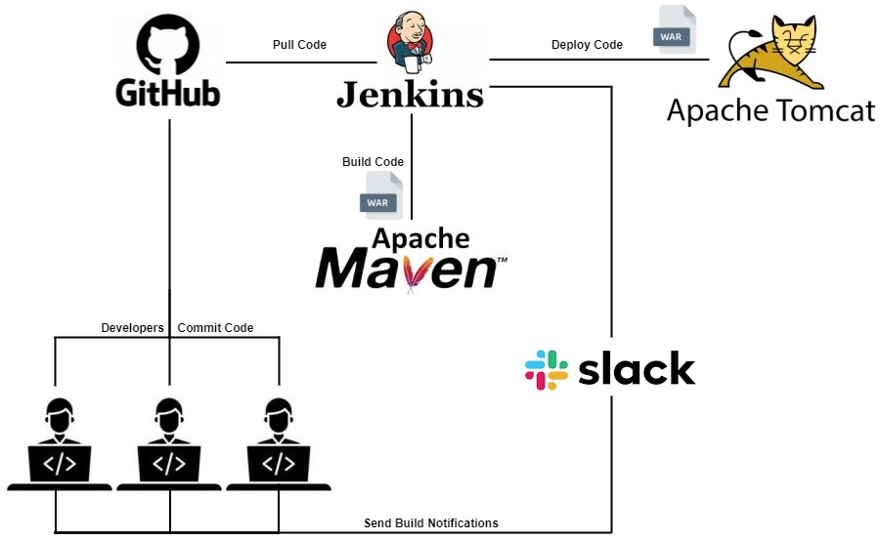](https://user-images.githubusercontent.com/119833411/241620850-56e50196-4555-473c-9c28-9f45625dbea5.jpg)

**Prerequisites:-**

* **Tomcat Server up and running.**
* **Jenkins Server up and running.**
* **Jenkins Integration with Slack Notification.**
* **A Java Project.**

**Reference:-**

* **Tomcat Setup** <https://github.com/sampathshivakumar/Installations/blob/main/Tomcat%20Installation%20on%20Amazon-Linux-2.md>
* **Jenkins Setup** <https://github.com/sampathshivakumar/Installations/blob/main/Jenkins%20Installation%20on%20Amazon-Linux-2.md>
* **Jenkins Integration with Slack Notification** <https://github.com/sampathshivakumar/Integrating-Jenkins-with-Slack-Notifications>
* **Java Project** https://github.com/Shivarajunayak/Java-Web-Apps.git

**Install Git in Jenkins Server.**

# Become a root

sudo su -

# Install git.

yum install git -y

# Check Version of git.

git version

**Open Jenkins in web-browser, click on manage jenkins then select Global Tool Configuration.**

[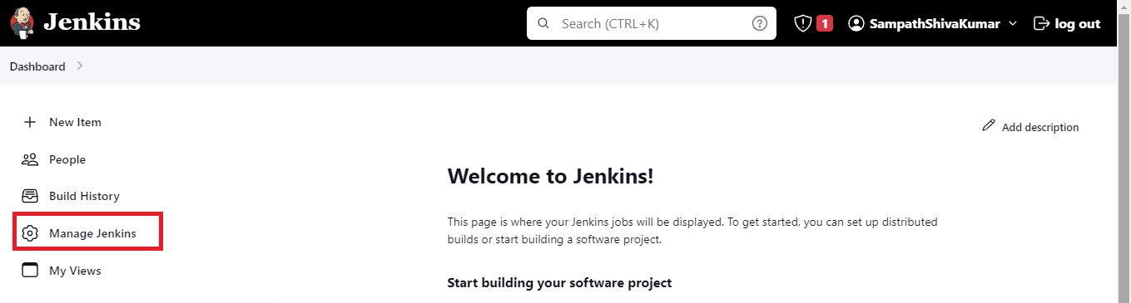](https://user-images.githubusercontent.com/119833411/241621062-d2cefe8c-660e-40be-8c30-99137a08356e.jpg)

[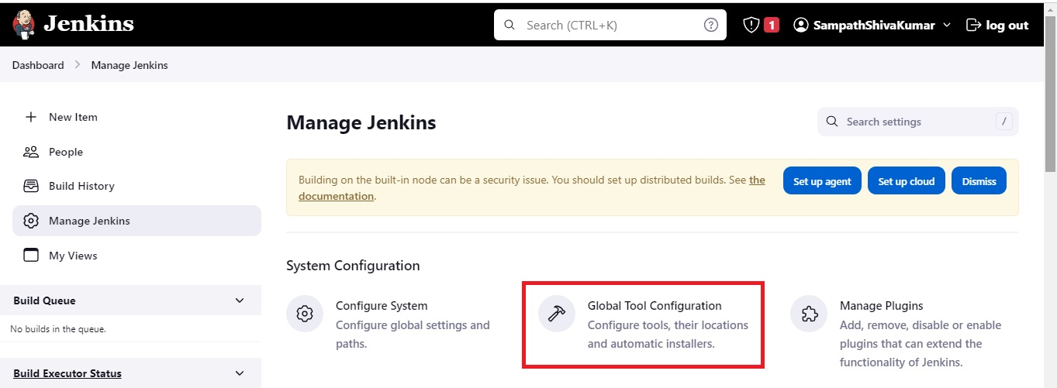](https://user-images.githubusercontent.com/119833411/241621114-39e07247-8c0d-4b11-9948-c907ea2a133a.jpg)

**In Git installations click Add git then select git.**

[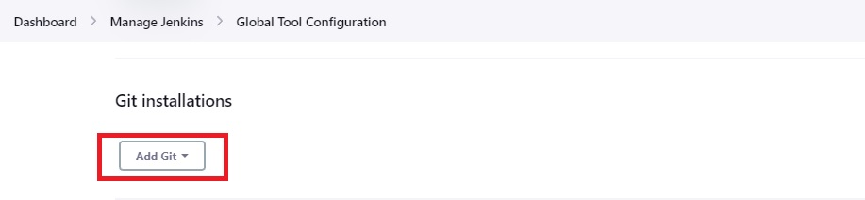](https://user-images.githubusercontent.com/119833411/241621155-b1810c0a-b603-476e-a6cc-3abc554e8c27.jpg)

[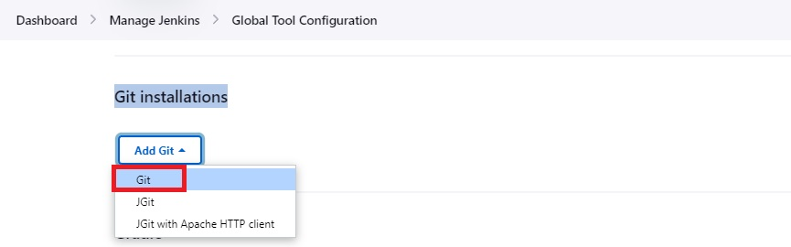](https://user-images.githubusercontent.com/119833411/241621182-b0fe0008-c576-4ea7-89aa-01238b0041c0.jpg)

**Enter Name and Path to Git executable as below then click apply and save.**

[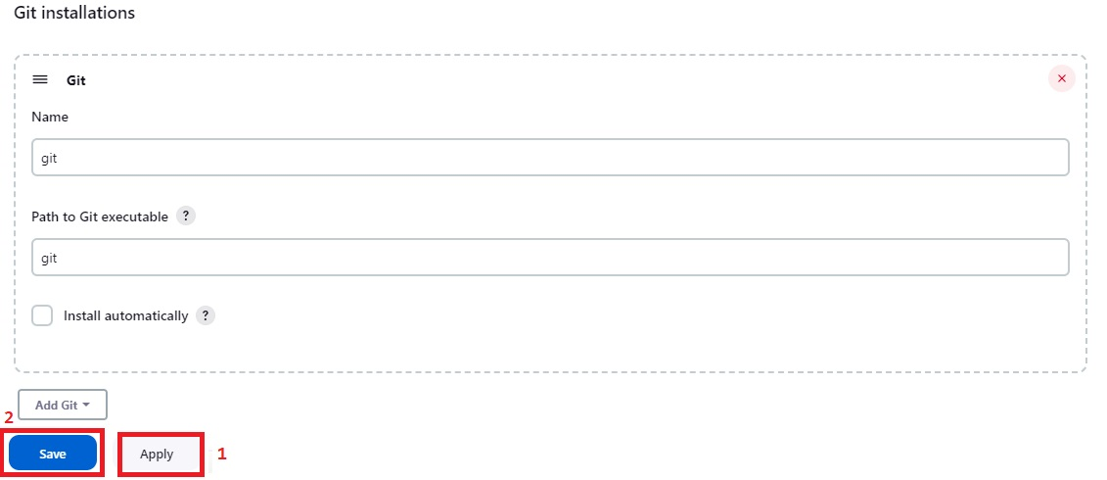](https://user-images.githubusercontent.com/119833411/241621236-5d289510-7b21-4601-964e-294102b66744.jpg)

**We have Successfully integrated Git with Jenkins.**

**Now go to Jenkins Dashboard select Manage Jenkins then click on Global Tool Configuration.**

[](https://user-images.githubusercontent.com/119833411/241621295-c89e6bec-9f91-4434-9da1-5fec167cb823.jpg)

**In Maven installations click Add Maven and give name and select Install automatically then Appy and Save.**

[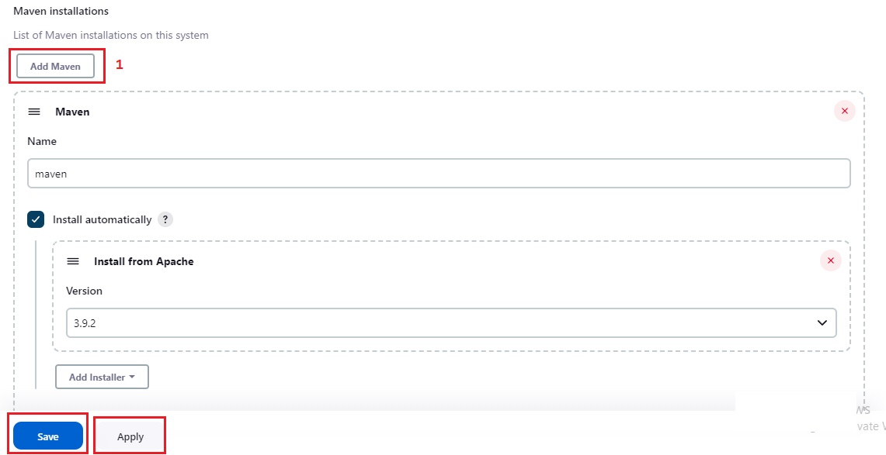](https://user-images.githubusercontent.com/119833411/241621319-f1fa80a5-b2da-4682-b2bb-fb2e779618a3.jpg)

**Maven is also Successfully integrated with Jenkins.**

**Install Deploy to container Plugin.**

[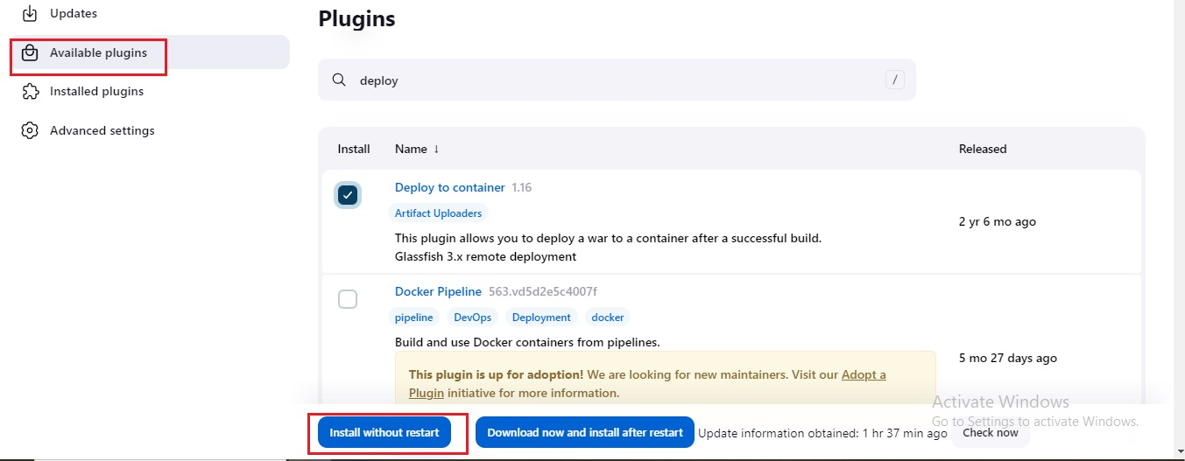](https://user-images.githubusercontent.com/119833411/241621349-9dce420f-edb8-443b-aeed-7572d4df1937.jpg)

[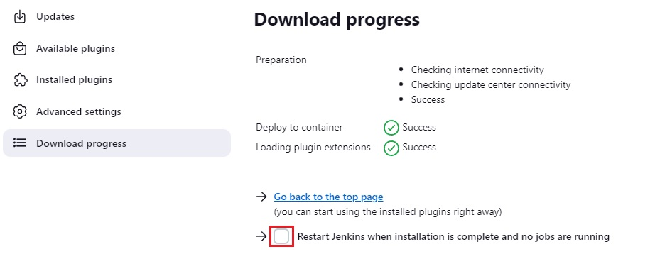](https://user-images.githubusercontent.com/119833411/241621433-323f6ef1-78e4-4cd1-a141-c57a8a088098.jpg)

**Add Tomcat user credentials in Jenkins Secrets.**

**You can check it in tomcat-user.xml** [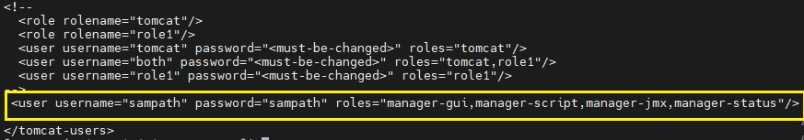](https://user-images.githubusercontent.com/119833411/241621570-cfe7dd3f-2001-4fad-bb17-f5d12ea3de89.jpg)

**Go to Manage Jenkins and Click on Credentials.**

[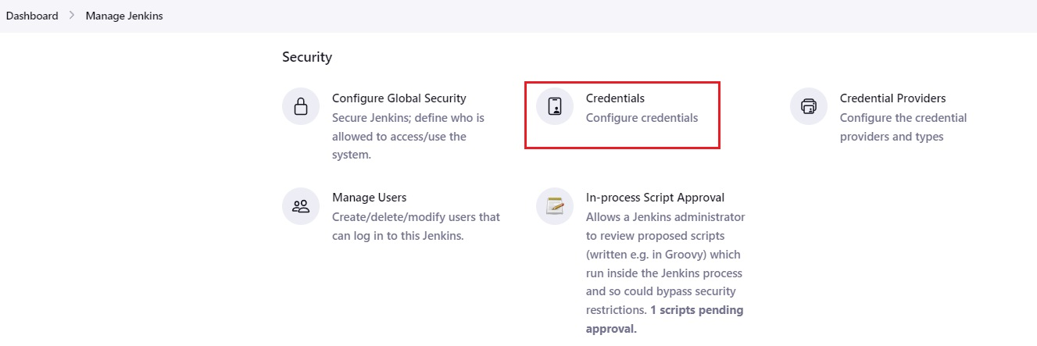](https://user-images.githubusercontent.com/119833411/241621645-d884ba46-3667-4ec0-8850-ff138562ad19.jpg)

**Select System.**

[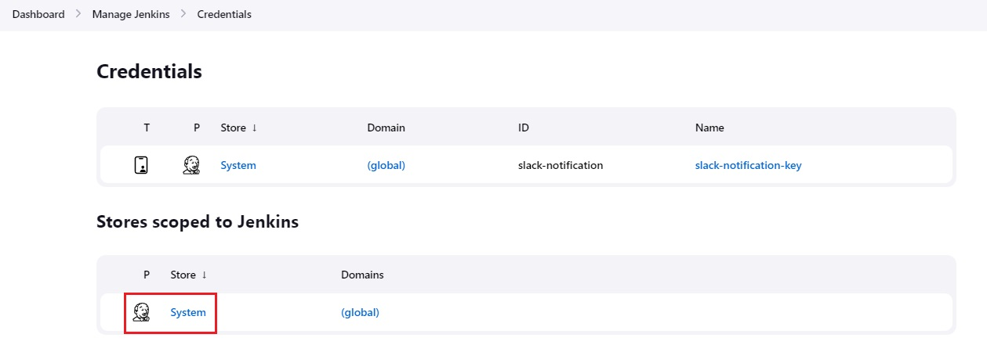](https://user-images.githubusercontent.com/119833411/241621674-b4a92551-16d1-4c6c-8282-6bcb6cda0f85.jpg)

**Select Global credentials (unrestricted).**

[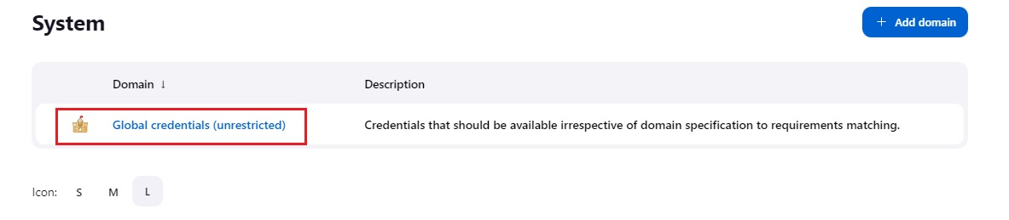](https://user-images.githubusercontent.com/119833411/241621690-0423eb07-9436-4086-916f-1054736b5e38.jpg)

**Select Add Credentials.**

[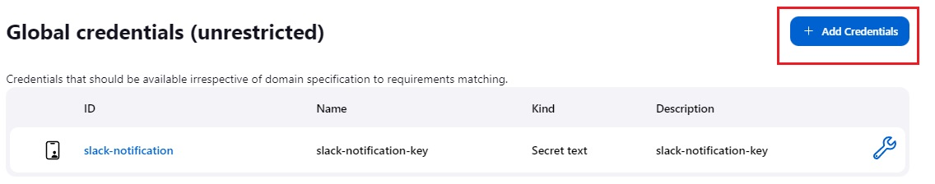](https://user-images.githubusercontent.com/119833411/241621716-bbfbb6e6-be17-4774-8a4d-a4bb6acb7625.jpg)

**Enter username and password.**

[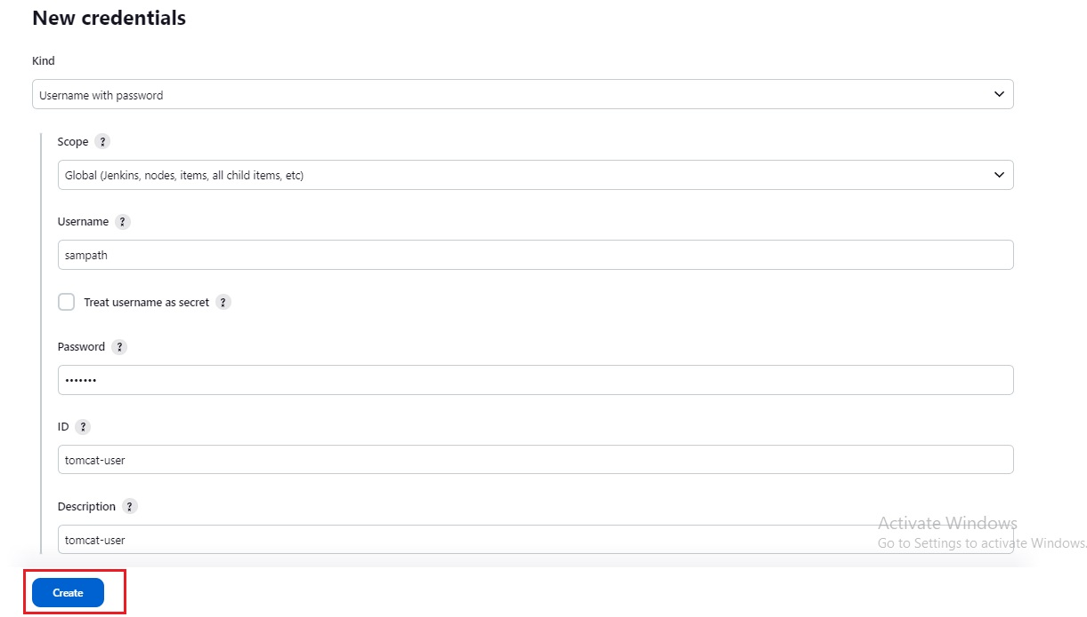](https://user-images.githubusercontent.com/119833411/241621744-e2004c8c-ab1b-4cbc-9d47-a59fe4d1d8a5.jpg)

**Once done you should see like this.**

[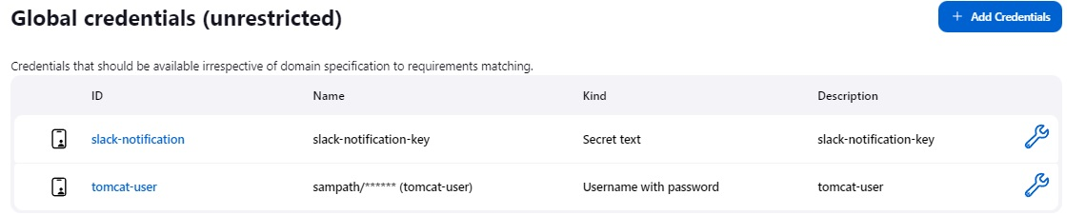](https://user-images.githubusercontent.com/119833411/241621768-141b91dc-92a8-4b6f-8dc0-b5c98947e38d.jpg)

**Now lets create a Jenkins job.**

[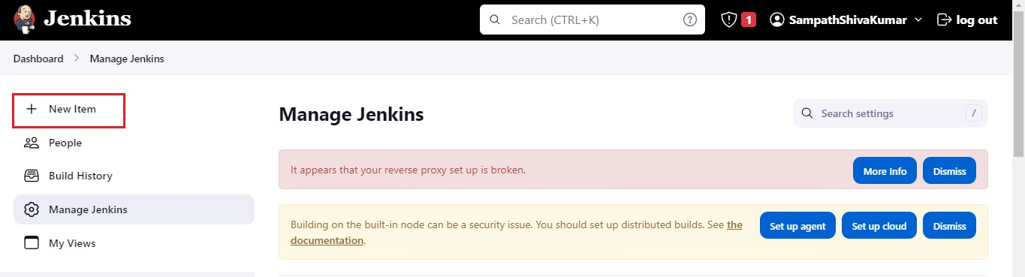](https://user-images.githubusercontent.com/119833411/241621809-61a721b2-aa53-43b7-9ccb-5338a6fc1d6e.jpg)

[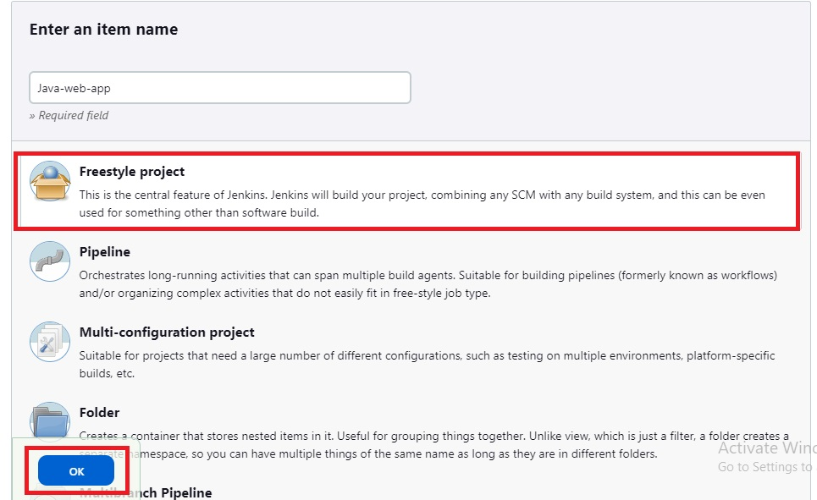](https://user-images.githubusercontent.com/119833411/241621867-9cade719-d908-42f6-bb7b-8f615945df81.jpg)

[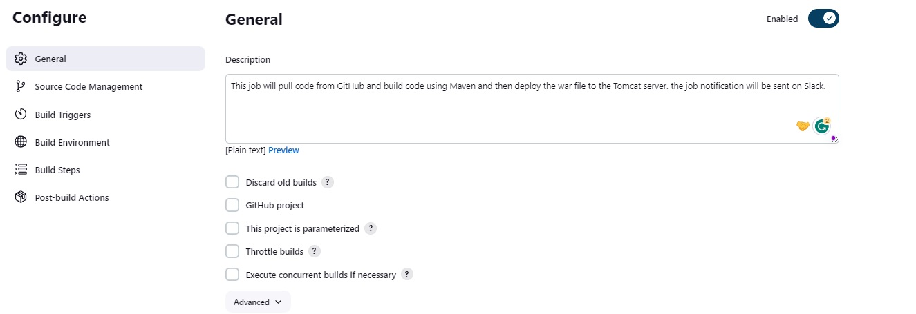](https://user-images.githubusercontent.com/119833411/241621890-636ca131-ede0-467d-a974-072906f7bafb.jpg)

[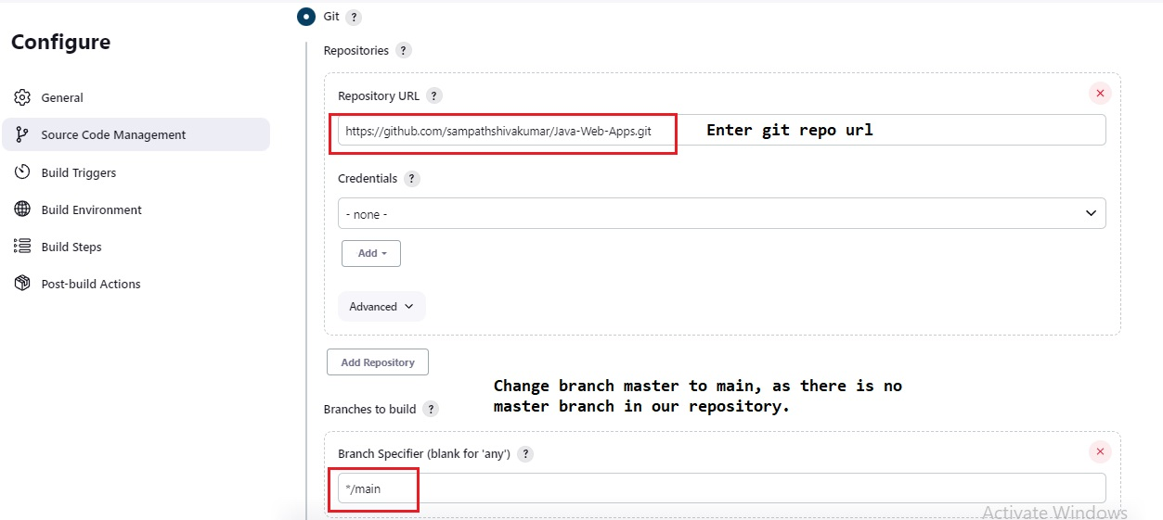](https://user-images.githubusercontent.com/119833411/241621914-4e616b79-00f5-4f1c-88dd-c587fbca2ae7.jpg)

**Provide Build details.**

[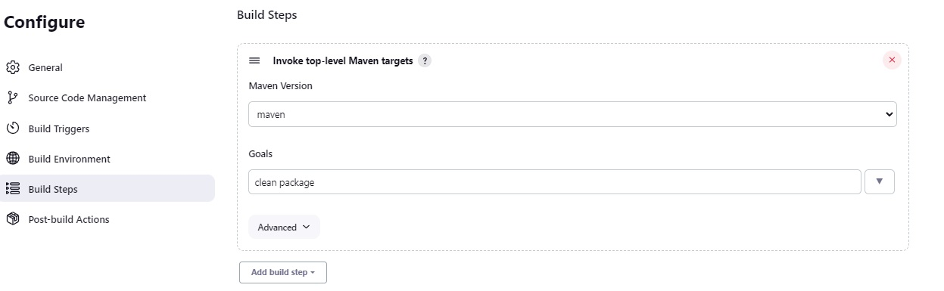](https://user-images.githubusercontent.com/119833411/241621999-458b2ddd-3818-41bc-b5a8-4f22e3b90655.jpg)

**In Post-build Actions click Add Post-build Actions and Select Slack Notification and select following and click apply and save.**

[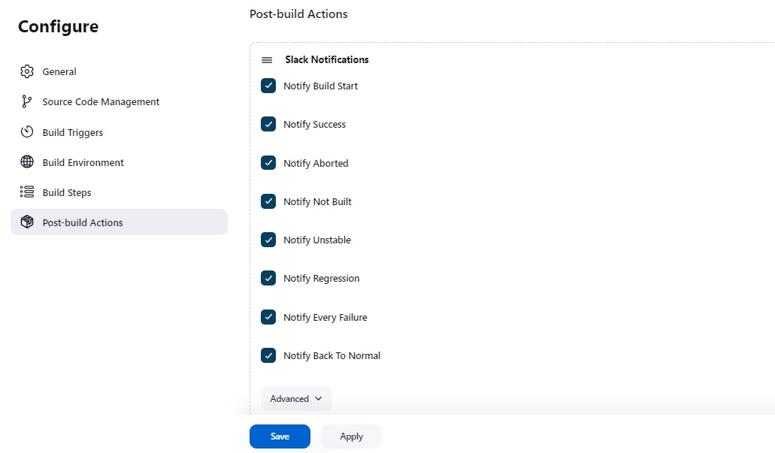](https://user-images.githubusercontent.com/119833411/241622018-1ad74371-8800-41e5-8a64-20f82ce381f5.jpg)

**In Post-build Actions click Add Post-build Actions and Select Deploy war/ear to container.**

[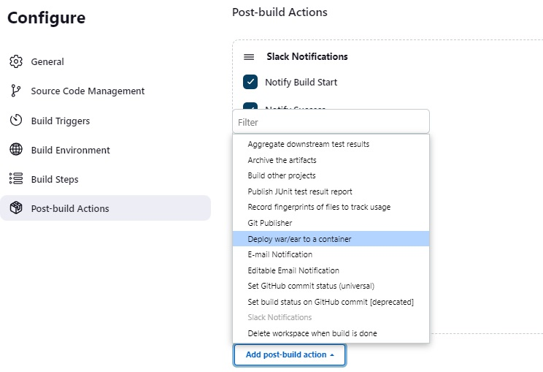](https://user-images.githubusercontent.com/119833411/241622162-0b67dcee-b579-42a6-9366-3d3c96cde1a8.jpg)

**Enter the details as following then click on apply and save.**

[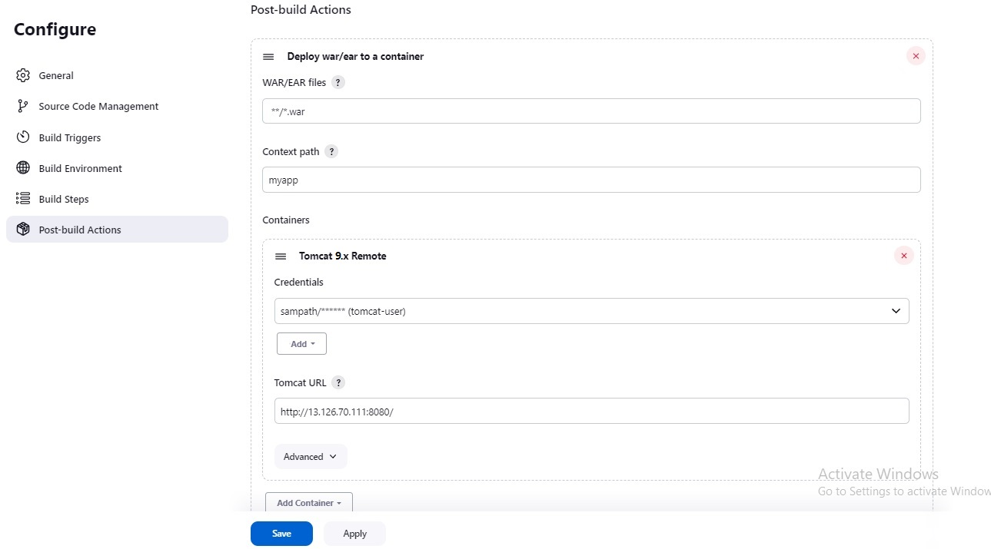](https://user-images.githubusercontent.com/119833411/241622189-406715a7-c28b-4d56-8254-73e742423066.jpg)

**Now Click Build Now.**

[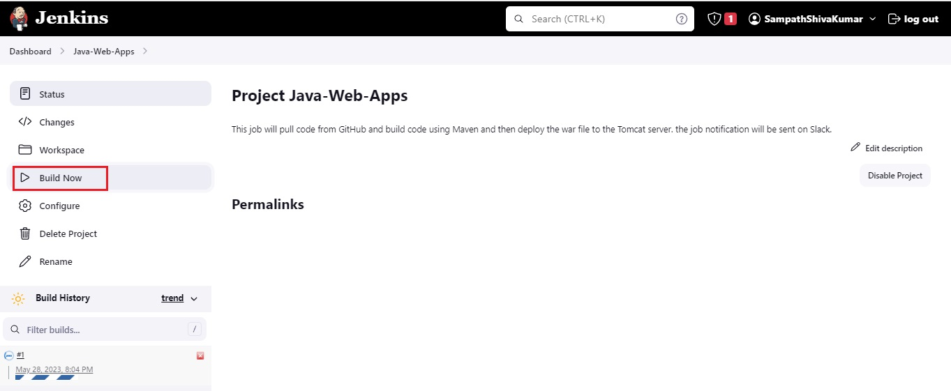](https://user-images.githubusercontent.com/119833411/241622269-b16c695a-a558-48f6-a8d6-ad893ccd16bd.jpg)

**Build Successfull.**

[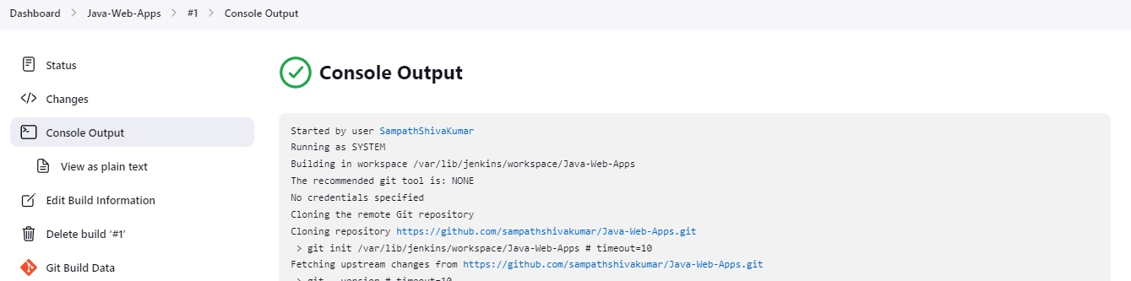](https://user-images.githubusercontent.com/119833411/241622328-ae80c3cf-8b0a-45d6-b441-345b342c267a.jpg)

**Slack Notifications.**

[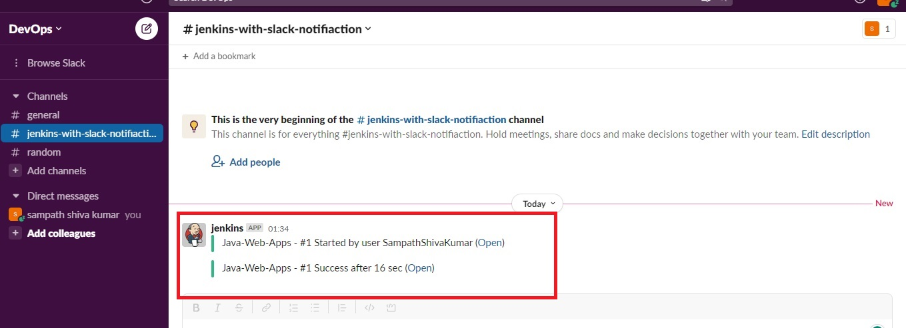](https://user-images.githubusercontent.com/119833411/241622388-8d533474-572c-4026-aada-0d57a62c7e41.jpg)

**Output.**

[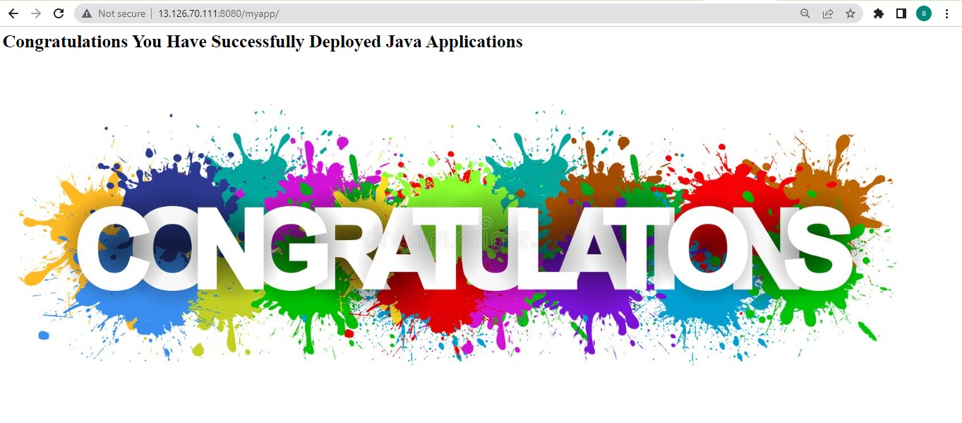](https://user-images.githubusercontent.com/119833411/241622446-c1d09f6d-4c13-4f7a-a18c-6510fe7f783b.jpg)

**Project is Successfully Completed.**

**Thank you for reading this post!**